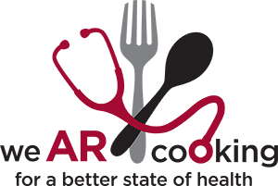

CULINARY MEDICINE PROGRAM 1ST FLOOR DONALD W REYNOLDS INSTITUTE ON AGING 629 JACK STEPHENS DRIVE LITTLE ROCK AR 72205

**ALLERGENS STATEMENT**

Attention participants with food allergies. Please be aware that our food may contain or come into contact with common allergens, such as dairy, eggs, wheat, soybeans, tree nuts, peanuts, fish, shellfish or wheat. While we take steps to minimize risk and safely handle the foods that contain potential allergens, please be advised that cross contamination may occur, as factors beyond our reasonable control may alter the formulations of the food we serve, or manufacturers may change their formulations without our knowledge.

If you are living a food allergy, please contact Alyssa Frisby, MS, RD, LD at culinarymedicine@uams.edu prior to program enrollment. The culinary medicine team requests to be notified of a food allergy two weeks prior to program start date to discuss accommodations.

I, _____________________*(Participant Name),* have read the above food allergy declaimer form and understand the language of the above request:

Participant Print Name (If under 18 legal guardian): ___________________________

Participant Signature (If under 18 legal guardian): _____________________________

Date: ________________________________________________________________