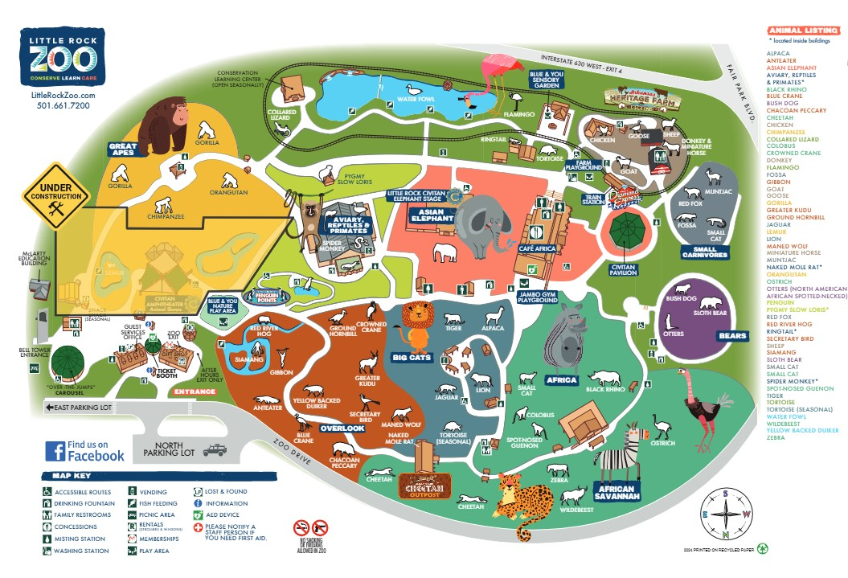
Golf Cart Pick Up/Drop Off

