Curbside
Welcome to Curbside! Curbside is a 3rd-party application that can assist you in placing orders while viewing protocols or workflows based upon patient scoring tools. Curbside is strictly optional, but is easily accessible in Epic.
You will learn how to access Curbside, find a protocol or workflow, queue up orders from Curbside, and place the orders in the patient chart. Throughout the Tip Sheet, you will find key tips for making Curbside an effective tool, bolded in blue.

Accessing Curbside in Epic
Curbside can be accessed from your Activities menu.
- Enter a patient’s chart.
- Select More (the down arrow) on Epic’s Activities toolbar.
- Select Curbside from the drop-down menu) to launch.
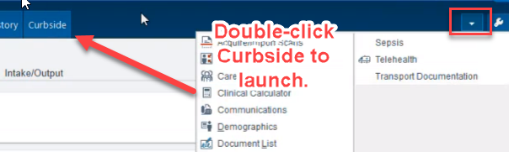

Curbside Navigation and Icons
You can zoom in and out of Curbside and pan around the screen.
- To zoom in on a protocol or workflow:
  - Use the scroll on your mouse
- To pan around the screen:
  - Click and hold the diamond cursor box and move it around
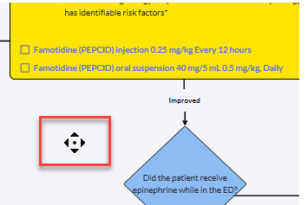

There are several icons in Curbside to point out:
- The grocery cart
  - The grocery cart lets you know how many orders you have queued up
- The note icon
  - IF you wanted to begin a note (NOT required), you could begin a note in Curbside and then copy and paste it into a note in Epic.
- Home
  - Selecting Home will take you back to the list of protocols and workflows
- Left and right arrow
  - This will move you back and forward in screens
- The arrows in the blue tab
  - Allows you to open and close the queued orders sidebar
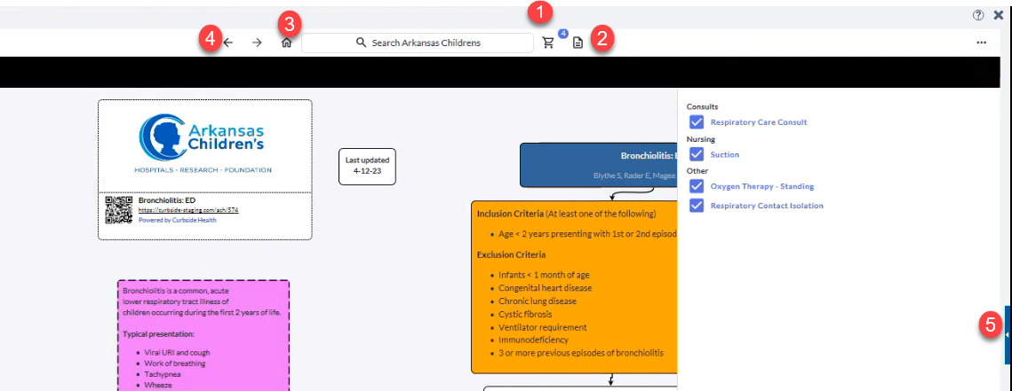

Choosing a Protocol or Workflow
Once Curbside has launched, you can search for your protocol or workflow. There are several ways to find the protocol or workflow you want to use.
- Scroll through the list and utilizing SHOW MORE to see more options
- Select Categories and find the appropriate category in which your protocol or workflow would be found
- Recommended: Use the Search field to find your protocol or workflow
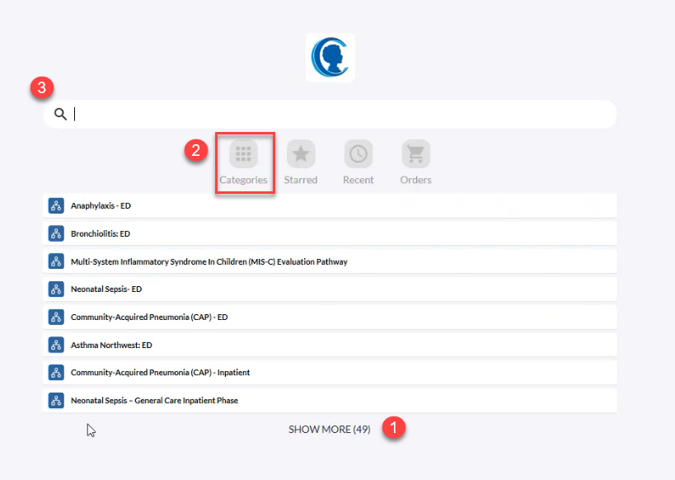
- Open the pathway by double-clicking on it.

Utilizing Curbside to Queue Orders

Using a Pathway or Workflow to Queue Orders in Curbside
Once you have opened up the pathway, you can utilize it to make medical decisions. As you make decisions, suggested orders for the pathway will be in blue. From here, you can queue orders to be written and signed in Epic. It is important to note that you are only selecting orders that you want to place in Epic. By selecting an order on the pathway, you are not placing that order.
Curbside use is discouraged for orders associated with patient movement – Admission and Transfer – since when you send the orders to the Epic Orders sidebar, you cannot sign and hold your orders.
When using a Pathway in Curbside:
- As you are following the pathway, some orders are suggested. For example, in the Bronchiolitis ED pathway, during initial assessment, you want to place the Oxygen Therapy - Standing order shown as a blue link in this pathway. To queue up the order, you place a checkmark next to the order.
- The sidebar opens and you can see the order you queued up.
- Place as many orders from the Pathway as needed.
- Once you have chosen your orders, select Send Orders to send them to the Orders sidebar in Epic.
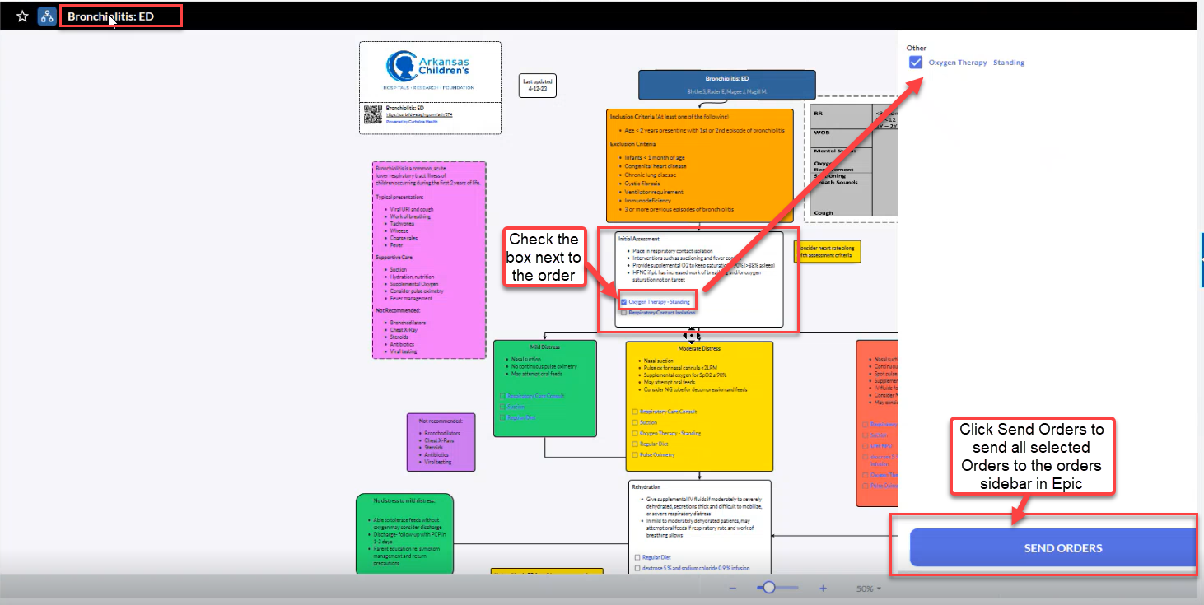

It is important to note that if a pathway give you an option to order one of several similar orders – for example, the pathways suggests you order one of 3 different antibiotics, there is no single-select safeguard in Curbside. You could potentially queue up all 3 antibiotics and send to Epic’s Orders sidebar.

When using a Workflow in Curbside:
- When the workflow opens, you choose the risk score associated with the workflow for the patient.
- Once you choose the score, the orders are automatically queued up for you. For example, if you choose High for the Bronchiolitis – Inpatient workflow, the orders associated with this risk score are queued up for you.
If you do not want to have certain orders sent to the orders sidebar in Epic, you can deselect them from the queue.
- Once you have chosen the orders that you want, select Send Orders to send them to the Orders sidebar in Epic.
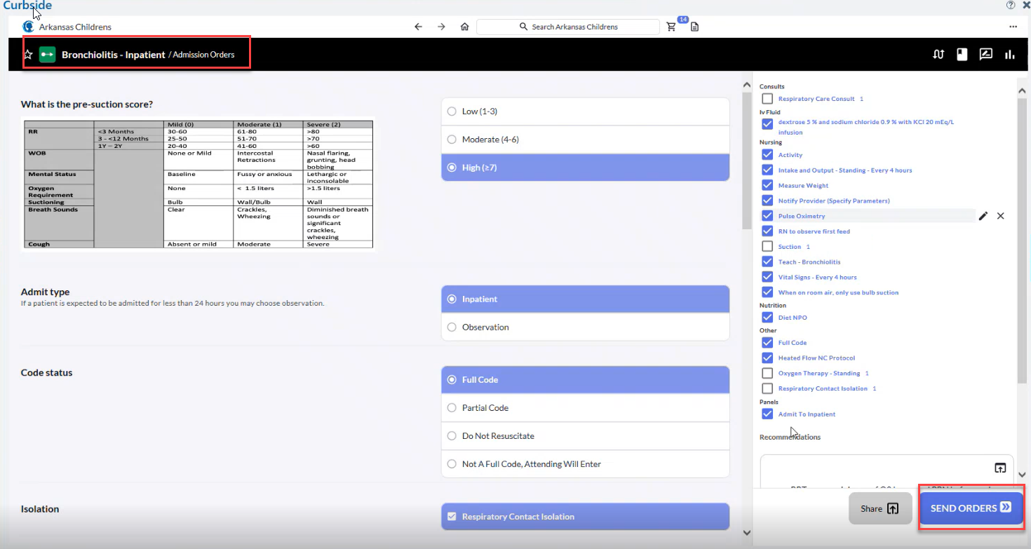

Duplication of Orders
There are some important points to keep in mind when using Curbside as it relates to duplicate orders.
You may see a number after the order that you have queued in Curbside. The number indicates that this MAY be a duplicate order.
If you see a number after a queued order, it is telling you that the order has been queued up in Curbside before and sent to the Orders sidebar in Epic. It does NOT mean that it has actually been ordered on the patient.
Notice that the orders are not checked. If you selected Send Orders to send to the Orders sidebar in Epic, the orders would not be sent.
If you want to order them, select the checkmarks next to the order and then select Send Orders.
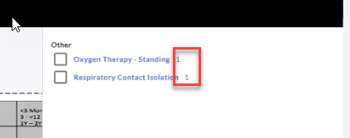

Signing Orders in Epic’s Orders sidebar
Once you select Send Orders in Curbside, you will be re-directed to Epic’s Orders sidebar to finish writing and signing your orders.
- Complete order details as you normally would in Epic.
- Pay attention to any duplicate orders warnings in Epic as it will tell you if there is an active duplicate order.
- Sign your orders in Epic as usual when you are done.
