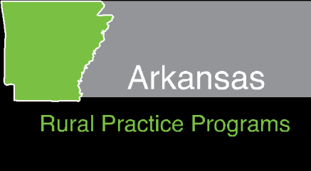
Community Match Rural
Physician Recruitment Program
Physician Application – 2022-2023

Please PRINT or write legibly. Use black ink. Return this application to the Rural Practice Program Administrator before January 10, 2022. In order for this to be accepted, your community must submit the Community Application by January 10, 2022.

Name: __________________________________ Date: ____________________________

Phone number: ___________________________ E-mail: ___________________________

Current Address: ________________________________________________________________________________

________________________________________________________________________________

Requested Contract Community and Community Designee: ____________________________________________________________________

What type of Primary Care Medicine would you plan to practice full time in this community? (Primary Care for purposes of this program is defined as: Family Medicine, General Internal Medicine, General Internal Medicine and Pediatrics, General Pediatrics, General Obstetrics and Gynecology, General Surgery, Geriatrics and Emergency Medicine)

________________________________________________________________________________

To be eligible, you must have graduated from an accredited medical school located in the United States OR you were an Arkansas resident BEFORE you entered an international medical school. List the medical school you attended and graduation date:

____________________________________________________________________

To be eligible, you must currently be in a residency training program or have completed a residency training program no more than two years prior to the date of application. List your residency training program(s) and date of completion or expected completion:

____________________________________________________________________

Will you or have you received any other funding from another state, federal, or scholarship program for practicing in this rural community? If yes, what program and what was the amount? (This includes any other service connected scholarships/loans/grants)

_______________________________________________________________________________

________________________________________________________________________________

Do you have any other obligations or commitments that would prevent you from completing four years of service in this rural community?
________________________________________________________________________________

What considerations led to your decision to practice primary care medicine in this rural community? Have you ever lived in this community or another rural community in Arkansas? ____________________________________________________________________

____________________________________________________________________

____________________________________________________________________

To what extent have you been exposed to and/or involved in the practice of medicine in a rural setting?

____________________________________________________________________

____________________________________________________________________
____________________________________________________________________

____________________________________________________________________

CERTIFICATION AND SIGNATURE:

I understand that the information submitted by me on this application will be used to assist the Arkansas Rural Medical Practice Student Loan and Scholarship Board in determining my eligibility for the Community Match Loan and Rural Physician Recruitment Program. I also understand that the number of accepted applicants is also based on the amount of available funds.

________________________________________________________________________________
SIGNATURE DATE
Complete and return this form to Rural Practice Program Administrator, 4301 West Markham, #551, Little Rock, AR 72205.

